Item 2 Task a
Through this task a GRANT statement is written in order to give the EXECUTE permission to the ‘dbo’ schema on the spN_ChefDetails stored procedure so then it will gain the ability to execute the stored procedure.

Note
Even though it is been tasked to grant EXECUTE permissions to the ‘dbo’ schema because dbo is the database owner it does have the permissions by default so the SQL server blocks the GRANT statements to this account so we had to face an error ‘Cannot grant, deny, or revoke permissions to sa, dbo, entity owner, information_schema, sys, or yourself.’.

Execution Results
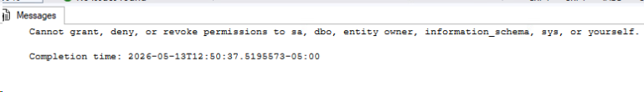
Figure 1 Execution results of item 2 task a

Item 2 task b
Through this task a GRANT statement is written in order to provide the ability to view the code for the second stored procedure spN_RecipeDetails to the Restaurant user. Through the GRANT statement it grants the VIEW DEFINITION permission so then the user is allowed to read the SQL script but prevents them being able to execute or break the code.

Execution Results

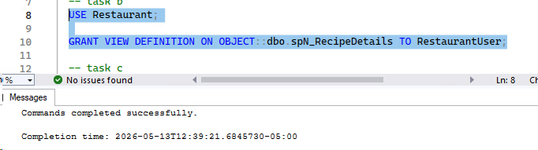
Figure 2 Execution results of item 2 task b

Item 2 task c
Through this task it assigns the ALTER permission to the RestaurantAddDeleteDb user. A GRANT ALTER statement is written for the third stored procedure spN_RecipeIngredientPrices to the RestaurantAddDeleteDb which lets the user to open the stored procedure and modify the code whenever they need to.

Execution Results
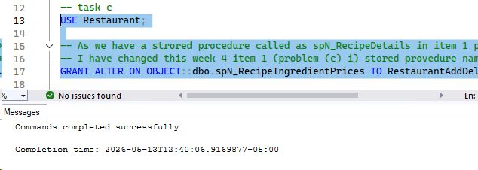
Figure 3 Execution results of item 2 task c

Item 2 task d
Through this GRANT command it gives the TAKE OWNERSHIP rights on the fourth stored procedure spN_KitchenDetails to the RestaurantPower user so then it allows the user to transfer the administrative ownership of the stored procedure to themselves.

Execution Results
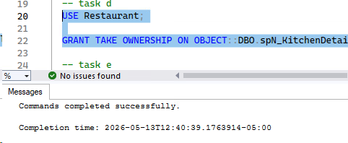
Figure 4 Execution results of item 2 task d

Item 2 task e
Through this GRANT command it grants the CONTROL permission on the store procedure spN_CustomerDetails to the RestaurantDoAnything user. CONTROL permission is the highest permission level that can be assigned to a database object, so it lets the user to execute, alter, view and whatever they want to do with the procedure without granting the permissions individually one by one.

Execution Results
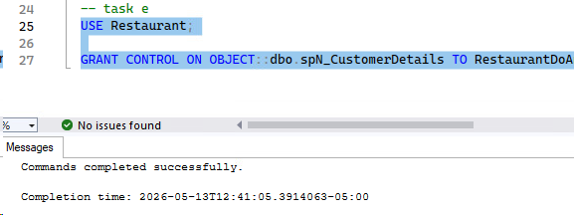
Figure 5 Execution results of item 2 task e

